Make a Smart Home in Tinkercad, using 2+ sensors, Led, Buzzer in single code and circuit

TEAM MEMBERS:

LAVANYA.V

PRIYADHARSHINI.M.D

PRIYANKA.S

NIVETHITHA.P

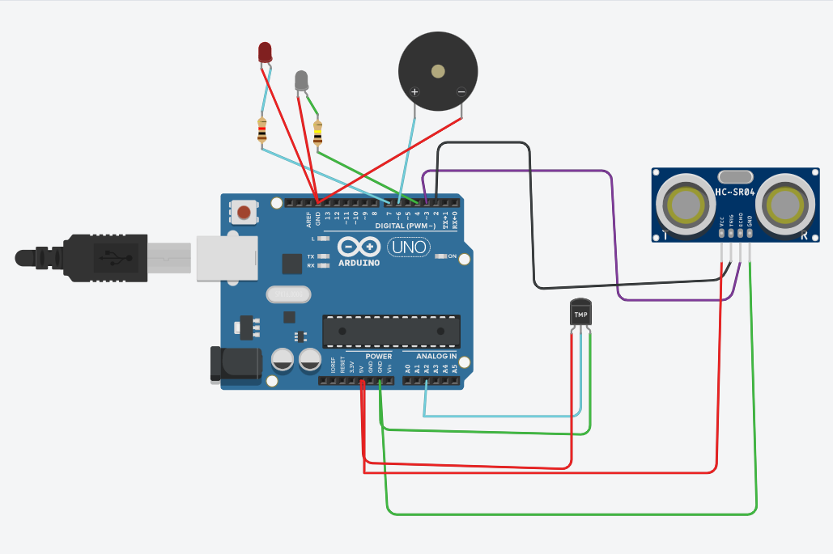

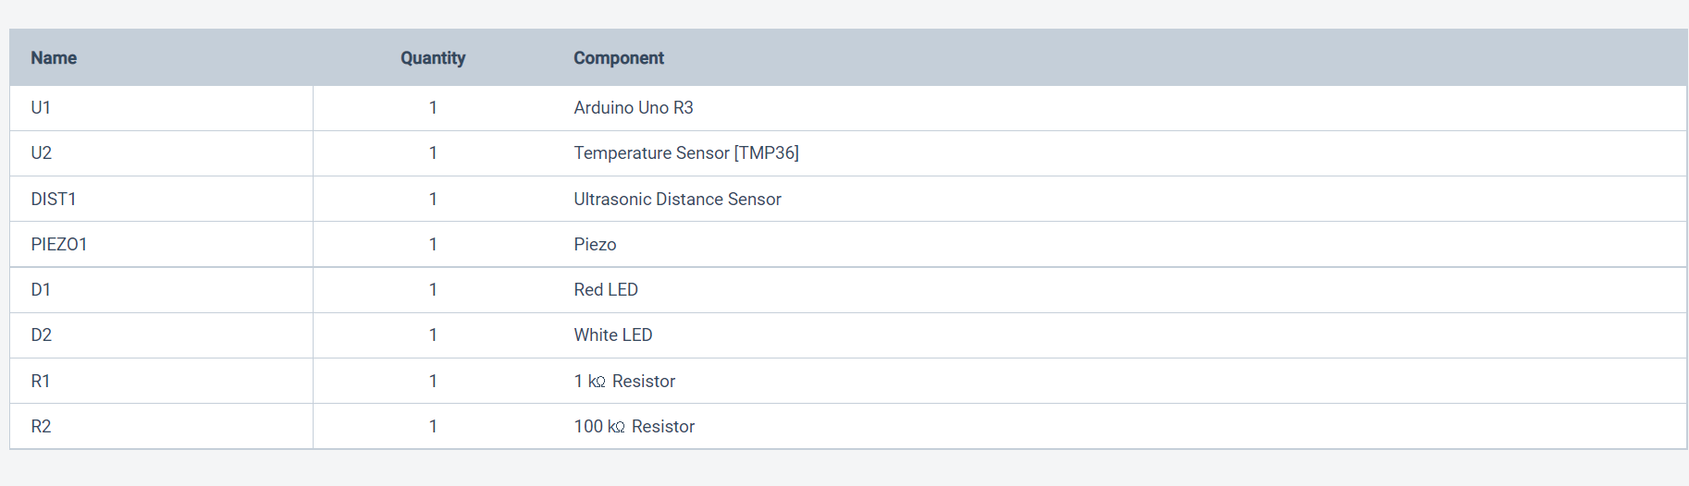

CODE:

// C++ code

int trig = 2; int echo = 3; int led=4; int buz=6; int led1=7; void setup()

{

Serial.begin(9600); pinMode(trig,OUTPUT); pinMode(echo,INPUT); pinMode(led,OUTPUT); pinMode(led1,OUTPUT); pinMode(buz,OUTPUT);

}

void loop()

{

// temperature sensor double t = analogRead(A2); Serial.print("Analog data: "); Serial.println(t);

double n= t/1024; double v=n\*5;

Serial.print("Voltage data: "); Serial.println(v);

double c=v-0.5; double k=v\*100;

Serial.print("Temperature value:"); Serial.println(k);

delay(1000);

//ultasonic sensor digitalWrite(trig,LOW); digitalWrite(trig,HIGH); delayMicroseconds(10); digitalWrite(trig,LOW);

float dur=pulseIn(echo,HIGH); float dist=(dur\*0.0343)/2; Serial.print("Distance in cm : "); Serial.println(dist);

//led if(dist>=100)

{

digitalWrite(led,HIGH);

}

else

{

digitalWrite(led,LOW);

}

//buzzer digitalWrite(buz,LOW); digitalWrite(led1,LOW); delay(1000); digitalWrite(buz,HIGH); digitalWrite(led1,HIGH);

delay(1000);

}

TINKERCARD LINK:

https://www.tinkercad.com/things/jSc9LqeJU3o